***4:*** ***PL/SQL***

**Exercise 7**

1. **Write a PL/SQL block to change address of a particular employee by taking his/her employee number interactively.**

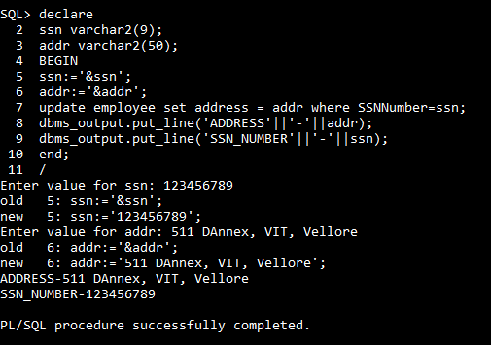

**Sample output**



1. **Write a PL/SQL block to display number of employees for each department.**

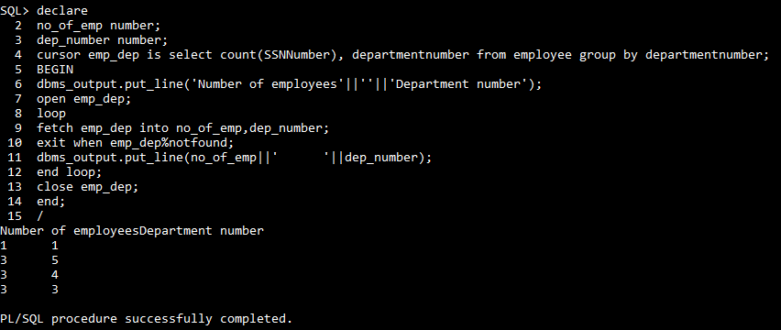

1. **Write a program to delete employee details who are having age >60.**

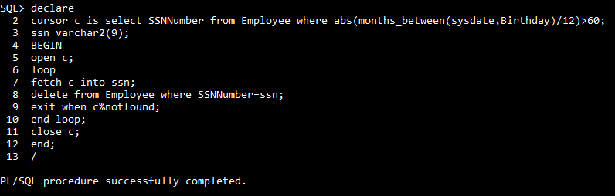

1. **Write a PL/SQL block to display employees who are top three earners in the company.**

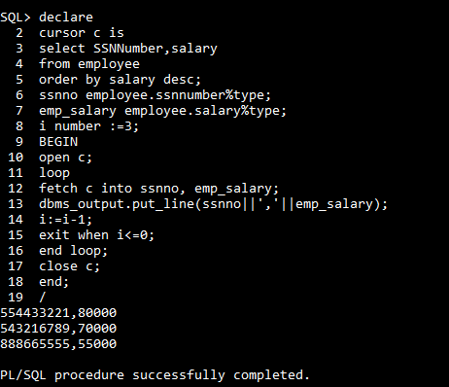

1. **Write a PL/SQL to delete records whose basic salary is <20000 from Emp table.**

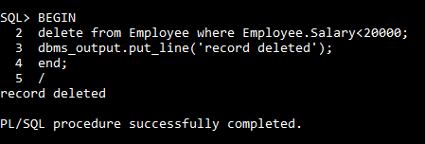

End of Exercise 7

Continue...

**Exercise 8:**

1. **Write a PL/SQL block to find the greatest of three numbers.**

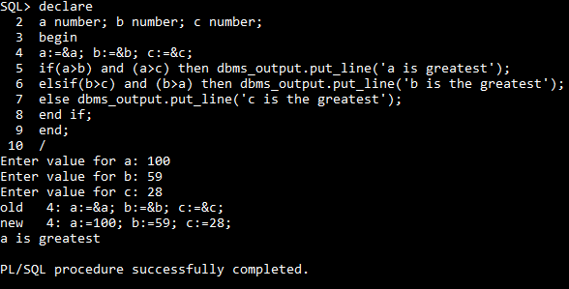

1. **Write a PL/SQL code to print the employee’s cadre based on their basic scales as given below (hint use: case selector….)**

|  |
| --- |
| Basic Scale Cadre |
| 45000 Manager |
| 35000 Supervisor |
| 25000 Worker |

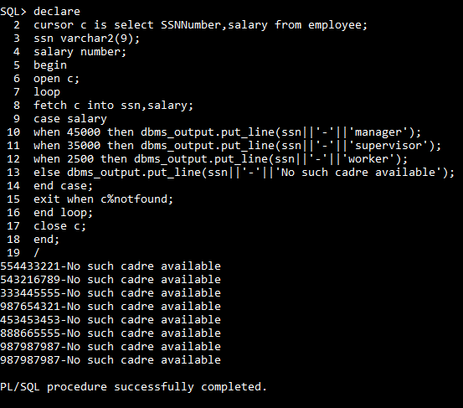

End of Exercise 8

Continue...

**Exercise 9:**

**Iterations**

1. **Write a PL/SQL code to print even number ranging between 1 and 100 in reverse order.**

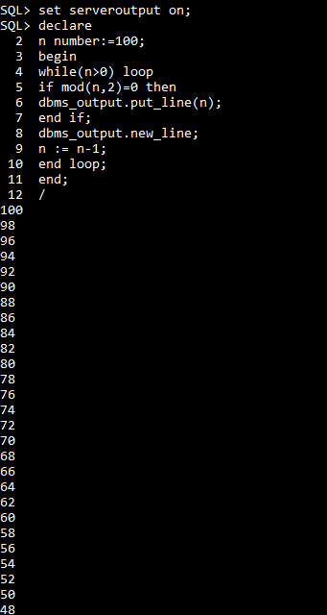

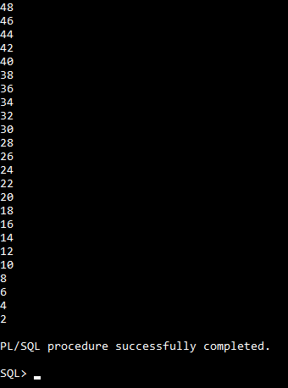

1. **Create a PL/SQL code to check whether the given number is palindrome or not.**

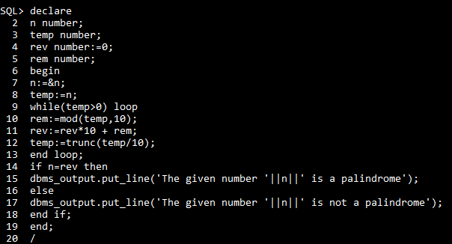

**Sample output for palindrome:**

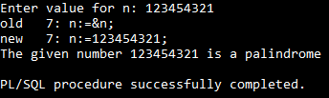

**Sample output for not palindrome case:**

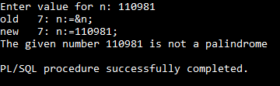

**Functions**

1. **Write a function to find out average, maximum and minimum salary for a given Department name.**

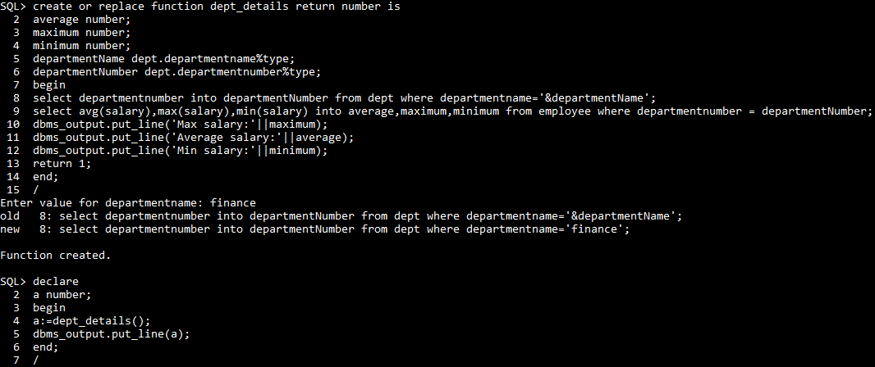

**Sample output**

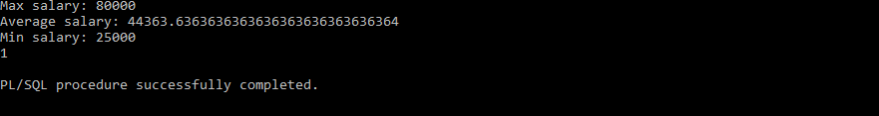

1. **Write a PL/SQL to find the factorial of the given number using function.**

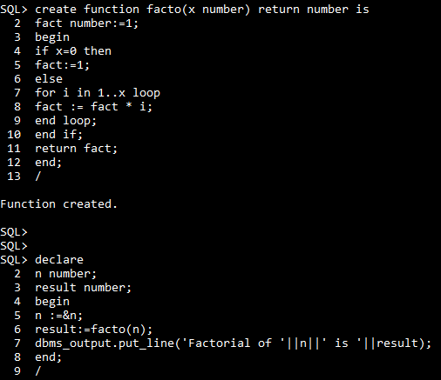

**Sample output1:**

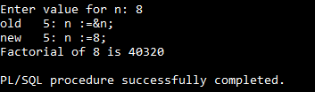

**Sample output2:**

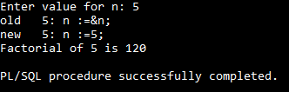

**Procedure**

1. **Write a procedure to accept an employee name and display his department details.**

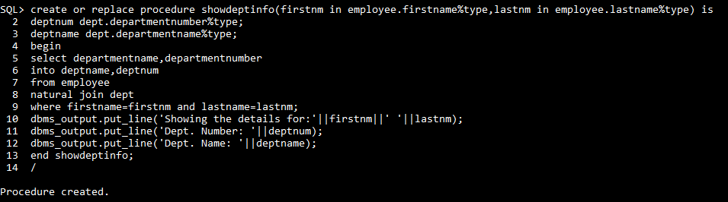

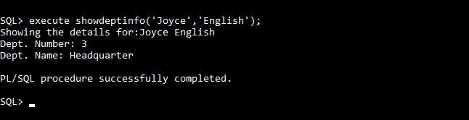

End of Exercise 9